
Call for application:
SAARC PhD Scholarship programme 2024
in ‘Agri Business Management/Soil Science/Agri Chemistry/Plant Pathology ‘from Maldives
By
SAARC Agriculture Centre
Background
SAARC Agriculture Centre (SAC) under the framework of SAARC has been working relentlessly for strengthening agricultural research and development through regional networks with diﬀerent institutions in South Asia. From 2017 onwards, the SAC has taken initiatives ‘SAARC Agriculture PhD Scholarship Programme’ to support aspiring agricultural professionals of the region for undertaking doctoral study in the premier Institute/ University of the SAARC region. The scholarship is highly competitive and merit based providing opportunities to the regular employees of the National Agricultural Research System (NARS)/ Department/ Ministry in SAARC Member States. Till date, the SAARC PhD scholarship has been awarded in ‘Soil Science’ to the candidate of Bangladesh studied at Bangladesh Agricultural University, Mymensingh, Bangladesh, in ‘Agricultural Economics’ to the aspirant of Afghanistan studied at University of Peradeniya, Sri Lanka, in ‘Molecular Biology & Biotechnology’ to the candidate of Nepal for undertaking study at Indian Agricultural Research Institute, New Delhi, India, in ‘Animal Nutrition’ to the applicant of India for pursuing study at Indian Veterinary Research Institute, Izatnagar, India and in the discipline of ‘Fish Nutrition & Feed Technology’ to the candidate of India for undertaking study at Central Institute of Fisheries Education, Mumbai, India, in ‘Fisheries Economics’ to the applicant of Sri Lanka for pursuing study at PGIA under the university of Peradeniya Sri Lanka.

Eligibility
For the academic year 2024, two scholarships will be offered in ‘Agri Business Management/Soil Science/Agri Chemistry/Plant Pathology’ (for the citizen of Maldives) as recommended by the Governing Board of the SAARC Agriculture Centre. The other criteria for the applicants are: (i) regular employee of the National Agricultural Research System/ Ministry/ Department, (ii) below the age of 40 years as on the date of application deadline, (iii) more than three years of service experience, (iv) good command of spoken and written English, (v) available for full time PhD for a period of three years.
Educational qualification for PhD in Agri Business Management
Master Degree (MSc/MS) in Agri Business/ Agri economics/ Agri marketing

Educational qualification for PhD in Soil Science
Master Degree (MSc/MS) in Soil Science

Educational qualification for PhD in Agri Chemistry
Master Degree (MSc/MS) in Chemistry /Agri Chemistry

Educational qualification for PhD in Plant Pathology
Master Degree (MSc/MS) in Plant Pathology

How to apply
Applications are invited from potential candidates of Maldives for pursuing doctoral study in the discipline of ‘Agri Business Management/Soil Science/Agri Chemistry/Plant Pathology’. Candidates should submit application along with supporting documents (attested copies of postgraduate and basic degree certiﬁcates, mark sheet/ report card, medals/ scholarship/ peer recognition received, research paper/ short note/ review/ bulletin/ book/ book chapter published, and a synopsis of research proposal) to the Director, SAC through the current employer /relevant Ministry/SAARC Division/ Section of the Ministry of Foreign Aﬀairs / External Aﬀairs of the home country on or before 24th October 2024. In case, the candidate perceives delay in forwarding the application through concerned ministry, he/she could submit the duly filled application signed by self and employer along with supporting documents directly to Dr. Md. Harunur Rashid, Director, SAC (director@sac.org.bd) as an advance copy. Notification regarding the scholarship and application format is available in the SAC website (www.sac.org.bd).
PhD synopsis
Applicants are requested to submit a synopsis (brief proposal) of maximum 5000 words for PhD research adhering to the format i.e., title, introduction, justification, objectives, and expected outcome. The proposal should be prepared up based on the South Asian challenges of agriculture and allied sectors. The synopsis will be evaluated for preparing the merit list along with other evaluation criteria. The expected outcomes of synopsis should lead to the advancement of knowledge and innovation in the particular subject for the benefit of the South Asian region.
Selection process
Applications received on or before the deadline (24th October,2024) will be evaluated by the Committee headed by the Director, SAARC Agriculture Centre as per the following criteria: (i) academic records, (ii) awards/medals/peer recognitions, (iii) research projects handled as principal investigator or co-investigator, (iv) courses taught, (v) work experience in subject areas, (vi) relevance and quality of PhD synopsis, (vii) publications, (viii) international exposure. The submitted applications will be ﬁnally evaluated based on the criteria mentioned above and selection will be made by the committee comprising of regional experts available at the Centre.
Tenure and placement
The SAARC Agriculture PhD Scholarship Programme is tenable for a period of three years as fulltime basis. During their doctoral study, candidates are not allowed to perform any kind of part time or contract job at the place of their study. The selected candidates are expected to be placed at the Postgraduate Institute of Agriculture, University of Peradeniya, Peradeniya, Sri Lanka. The SAARC Agriculture Centre will facilitate their admission.

Host Institute for the participant of Maldives
University of Peradeniya, Sri Lanka (For Bhutan) in establishing its identity at its inception in 1942, the then University of Ceylon decided that a coat-of-arms would not be in keeping with the traditions of an oriental country. Instead, it chose a seal with a lion motif that has remained the university’s logo over the years, although small changes were made during its transformation into the University of Peradeniya.

The original Logo of the university consisted of a lion - the lion being the symbol of Sri Lanka, surrounded by a circle containing the Sanskrit motto ‘Sarvasva Locanam Sastram’ (knowledge is the eye unto all) and the words University of Ceylon in English. Outside the circle was a design of 'Pala Pethi', a symbol of purity and wisdom in indigenous art, represented here by stylized lotus petals of the Kandyan Period.

In 1978, when the University of Peradeniya became an independent entity, the Council adopted the Logo of the University of Ceylon without the Sanskrit motto, but with the words University of Peradeniya in Sinhala, Tamil and English.

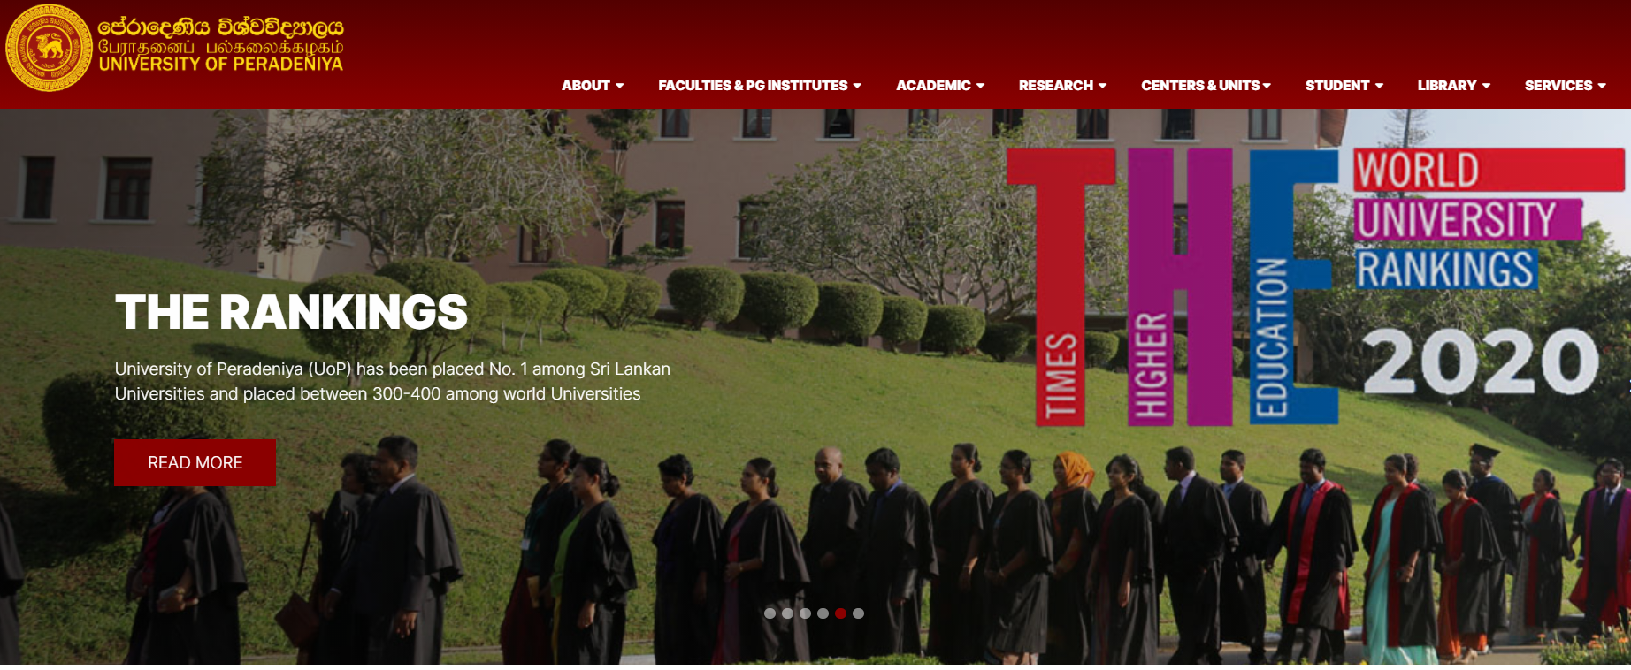

The Postgraduate Institute of Agriculture (PGIA), University of Peradeniya was established in 1975 with the main objective of developing in-country capacity for postgraduate education in agriculture and to provide appropriately trained scientific personnel for a rapidly expanding agricultural sector of the country. Over the past three decades, it has achieved substantial progress and has emerged as a “Centre of Excellence” in higher education in agricultural sciences in the country.
What covers under the SAARC Agriculture PhD Scholarship Programme?
- Economy class airfare from home country to the host institute. Eligible during joining and after the completion of study.
- Entire tuition fees as applicable to the University of Peradeniya, Peradeniya, Sri Lanka.
- Living allowance at the rate US$600 per month for three years.
- One-time grant of US$1000 to cover expenditure on books, study materials, computer and thesis preparation.
- A grant of US$1000 per year for three years to cover research cost with the recommendations of the PhD supervisor.
Grant conditions
The awardee is expected to strictly follow the guidelines of respective University at the host country. The award may be terminated at any time for reasons of unsatisfactory progress or attendance or if the registration is suspended or terminated by his/ her university for any reason. The awardee needs to execute a bond with the host Institute on behalf of SAARC Agriculture Centre, Dhaka for the successful completion of PhD programme. In case of candidates leaving the doctoral study before completion, they need to surrender the entire fellowship amount with interest to the SAARC Agriculture Centre, Dhaka. a hard and soft copy of the doctoral thesis needs to be submitted to the SAARC Agriculture Centre, Dhaka after completion of PhD.

Besides, the awardee should acknowledge the SAARC Agriculture Centre in all publications including PhD thesis.
Further contact
Dr. Md. Younus Ali
Senior Programme Specialist (Livestock)
SAARC Agriculture Centre
BARC Complex, Farmgate
Dhaka -1215, Bangladesh.
Phone No.: 00880241024785
Mobile No.: 008801716500276
Email: dryounusali1972@gmail.com

Dr. Md. Harunur Rashid
Director
SAARC Agriculture Centre
BARC Complex, Farmgate,
Dhaka -1215, Bangladesh
Phone No.: 00880241024778
Mobile No.: 008801716950421
Email: director@sac.org.bd

